 | Santa Barbara Amateur Radio Club, Inc.  P.O. Box 3907 Santa Barbara CA 93130-3907 www.sbarc.org | 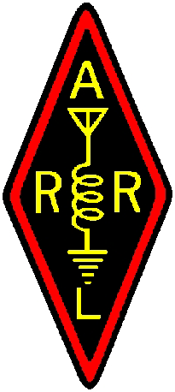

REPEATER TECH NOTES

20 August 2011

To: Net Control Managers
From: Bill Talanian, Trustee
Subject: SBARC Net Control Operations and Tactical ID’s

Guidelines

Part 97 of the FCC rules governing station identification is specific. However, under net operations when using tactical ID’s it has been observed that there is excessive ID’ing of stations by individual operators when not actively communicating in a series of transmissions. This tends to create a lot of radio traffic and subtracts from that of essential communications to get the message across. Tactical calls are used to better identify a location or a specific task, such as team 1, team 2, etc. The net control operator typically understands and recognizes each station as licensed operators in addition to maintaining order and discipline.

The FCC does not have special regulations for ARES or net operations. So long as the control operator maintains net discipline the Trustee is not recommending excessive ID’ing and consuming air time.

