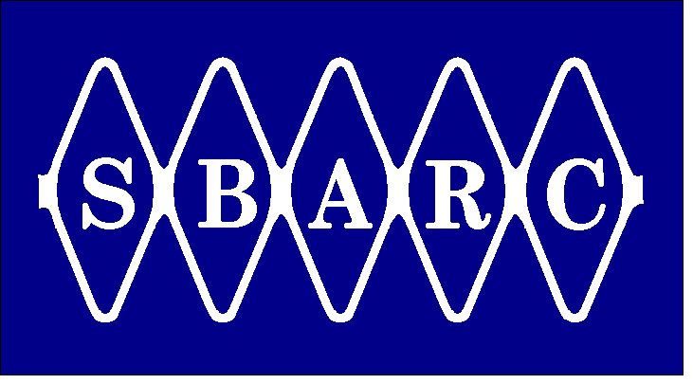 | Santa Barbara Amateur Radio Club Inc.  P.O. Box 3907 Santa Barbara CA 93130-3907 www.sbarc.org  A non-profit educational corporation | 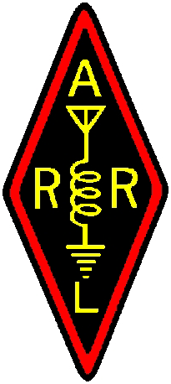
December 2012

SBARC TELECOMMUNICATIONS OPEN POSITION:
Contact: Bill Talanian or Andy Seybold

Repeater Control Systems Specialist

Repeater control systems specialist to maintain existing repeater and remote base control systems. Ability to upgrade and phase-in new RLC DSP404 type controllers.

- Hands-on medium to long term assignment for a radio communications control systems specialist to assist with legacy control system maintenance at six hill top venues. This will apply to the ACC series of repeater controllers; RC-85, RC-96, RC-850 and Link Communications RLC-2. This equipment has been in service up to 15-20 years.
- Ability to work from partial or incomplete documentation.
- Integrate remote monitors, receivers, transmitters, voters, power, and alarm systems.
- Program controllers for best syntax of voice prompt commands and user messages.
- Establish hierarchy control and Macro sets for next generation controller.
- Knowledge of commonly-used terms, concepts, practices, and procedures within the radio communications field.
- Establish programming control levels for operations personnel as directed.
- Develop and document signal path flow, block diagrams, pin outs, one line and data diagrams, installation, and as-built drawings using CAD program.
- Ability to interface wiring equivalent to mil-std or commercial grade.
- Self-starter who can work independently and reports to team leader.
- Must have background and willingness to function in an information secure environment.
- An excellent opportunity for both the seasoned veteran and/or someone who wants to learn these important skills. Single strong candidate desirable however, task can be a team effort.

