 | Santa Barbara Amateur Radio Club, Inc.  P.O. Box 3907 Santa Barbara CA 93130-3907 (805)569-5700 www.sbarc.org | 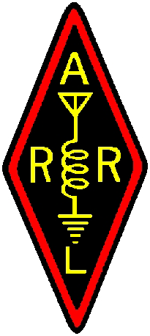

REPEATER TECH NOTES

Excerpts
CALIFORNIA PENAL CODE

(2) Except as provided by subdivision (d) of Section 653t, every
person who knowingly and maliciously interrupts, disrupts, impedes,
or otherwise interferes with the transmission of a communication over
a public safety radio frequency shall be punished by a fine not
exceeding one thousand dollars ($1,000), imprisonment in a county
jail not exceeding one year, or by both that fine and imprisonment.

(a) A person commits a public offense if the person knowingly
and maliciously interrupts, disrupts, impedes, or otherwise
interferes with the transmission of a communication over an amateur
or a citizen's band radio frequency, the purpose of which
communication is to inform or inquire about an emergency.
(b) For purposes of this section, "emergency" means a condition or
circumstance in which an individual is or is reasonably believed by
the person transmitting the communication to be in imminent danger of
serious bodily injury, in which property is or is reasonably
believed by the person transmitting the communication to be in
imminent danger of extensive damage or destruction, or in which that
injury or destruction has occurred and the person transmitting is
attempting to summon assistance.
(c) A violation of subdivision (a) is a misdemeanor punishable by
a fine not to exceed one thousand dollars ($1,000), by imprisonment
in a county jail not to exceed six months, or by both, unless, as a
result of the commission of the offense, serious bodily injury or
property loss in excess of ten thousand dollars ($10,000) occurs, in
which event the offense is a felony.
(d) Any person who knowingly and maliciously interrupts, disrupts,
impedes, or otherwise interferes with the transmission of an
emergency communication over a public safety radio frequency, when
the offense results in serious bodily injury or property loss in
excess of ten thousand dollars ($10,000), is guilty of a felony.

