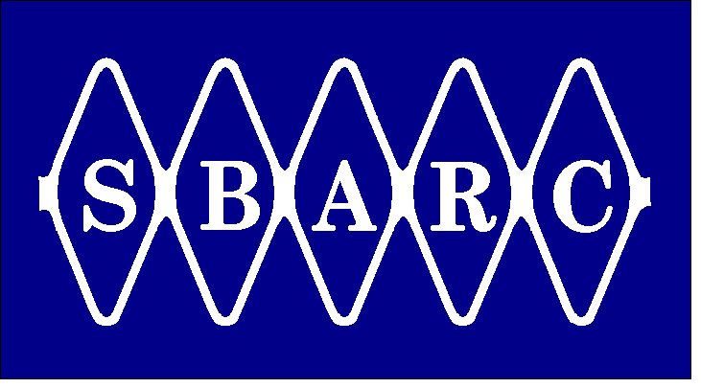 | Santa Barbara Amateur Radio Club Inc.  P.O. Box 3907 Santa Barbara CA 93130-3907 www.sbarc.org  A non-profit educational corporation | 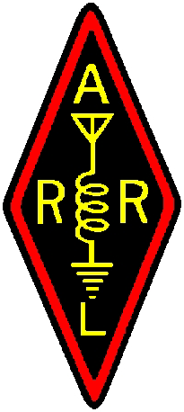

December 2012

QST QST QST

SBARC supports six major repeater sites and a number of major radio systems which is in need of hand tools, special tooling, bench items, and connectors for cable construction. If you are looking for an IRS tax deduction before years end and would like to support the telecom systems that you enjoy most we would appreciate any modest donation. Just send your check to the club treasurer at the club address and mark it repeater tools.
Many thanks for your support.

73 de w1uuq
Bill Talanian
Director

