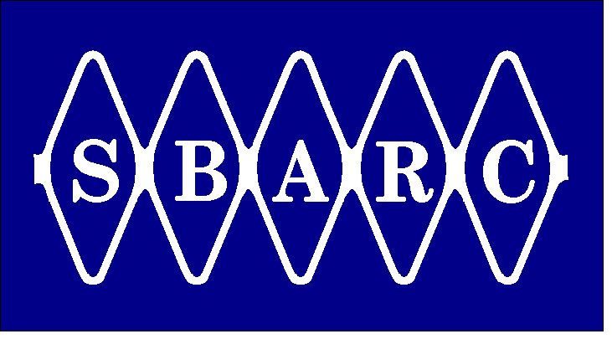 | Santa Barbara Amateur Radio Club, Inc.  P.O. Box 3907 Santa Barbara CA 93130-3907 (805)569-5700 www.sbarc.org | 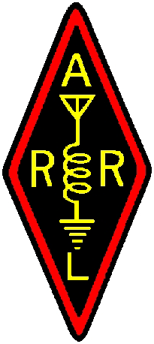

REPEATER TECH NOTES

5 May 2009

For the past several years SBARC in conjunction with UCSB has made available a 360 degree view of Santa Cruz Island from Diablo Peak. The innovation and technique of using a wireless system over 25 miles of a water path was ahead of its time. However, continuing maintenance of the system has become difficult due to an isolated location with infrequent access together with issues of mainland support. Until a long term solution is found SBARC will no longer offer this service. Should a forward plan emerge which offers a continuation of this asset then it is possible we will see a return of the Island webcam.

