 | Santa Barbara Amateur Radio Club, Inc.  P.O. Box 3907 Santa Barbara CA 93130-3907 www.sbarc.org  REPEATER TECH NOTES  December 2010 | 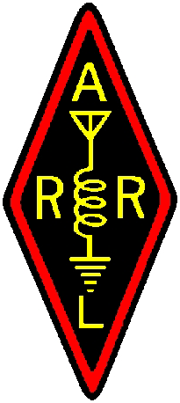

VERIZON LAND-LINE CONNECTIVITY
224.12 and 145.18 REPEATERS SANTA YNEZ PEAK

Several months ago SBARC decided to terminate the land-line Verizon telephone service at Santa Ynez Peak as a cost saving measure. The general lack of phone-patch use was due to expanding cell phone service which brought about our decision. After terminating the phone service it was noted that a dial tone still exists. It is our understanding that Verizon does not terminate the 911 capability when phone service is terminated. Should an emergency call be necessary simply use the emergency speed dial feature for 911 as it appears on your membership card.

Thanks to Verizon, we have a free line with the most important number still available if it becomes necessary.

